DevOps

DevOps Roadmap (Devops roadmap: Cloudchamp and ppt)
- SDLC
- Linux
- Programming Language(bash, python)
- Git for version control
- Learn any cloud platform(AWS,Azure,GCP)
- Devops, CI/CD Pipeline, Jenkins
- Infrastructure as Code()
- Microservices and Containerization
- Container Orchestration (Kubernetes)
- Monitor and Logging
- Gitops
- Service Mesh

- Software Development Life Cycle
Here’s how DevOps integrates into each phase of the SDLC:
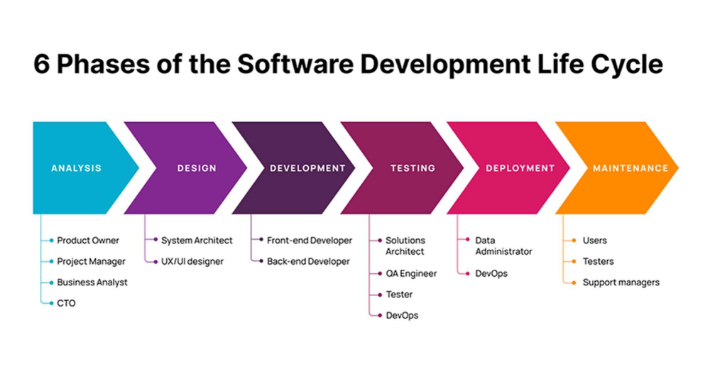
- Planning: The team decides to build an e-commerce website. They gather requirements like what features the website should have (e.g., product listings, shopping cart, payment gateway).
- Analysis: They analyze these requirements in detail. For example, they decide that the website needs to support multiple payment methods and have a user-friendly interface.
- Design: They create a blueprint of the website. This includes designing the layout, database structure, and user interface.
- Implementation (Coding): Developers start coding the website. They write the code for the product listings, shopping cart, and payment gateway.
- Testing: They test the website to make sure everything works correctly. This includes checking if users can add items to the cart, make payments, and if the website works on different devices.
- Deployment: Once testing is complete, they launch the website so customers can start using it.
- Maintenance: After the website is live, they continue to fix bugs, add new features, and ensure the website runs smoothly.

DevOps Integration with SDLC
- Planning:
  - Collaboration Tools: The team uses tools like JIRA to track tasks and collaborate effectively.
  - Continuous Feedback: They regularly gather feedback from stakeholders to refine the website’s features.
- Analysis:
  - Automated Documentation: They use tools to automatically update documentation whenever changes are made.
  - Version Control: They use Git to manage changes in the requirements and documentation.
- Design:
  - Infrastructure as Code (IaC): They design the website’s infrastructure using code, which can be easily versioned and automated.
  - Continuous Integration (CI): They frequently integrate code changes to detect issues early.
- Implementation (Coding):
  - CI/CD Pipelines: They set up pipelines to automate the build, test, and deployment processes.
  - Code Reviews and Automated Testing: They implement code reviews and automated tests to ensure code quality.
- Testing:
  - Automated Testing: They use automated tools to perform tests, ensuring the website works as expected.
  - Continuous Testing: Testing is integrated into the CI/CD pipeline for continuous validation.
- Deployment:
  - Continuous Deployment: They automate the deployment process to release updates quickly and reliably.
  - Containerization: They use containers (e.g., Docker) to ensure the website runs consistently across different environments.
- Maintenance:
  - Monitoring and Logging: They implement monitoring and logging to detect and resolve issues quickly.
  - Incident Management: They use tools for incident management and automated alerts to handle issues efficiently.

Example: Imagine the team is adding a new feature to the e-commerce website: a recommendation system that suggests products to users based on their browsing history.
- Planning: They decide to add this feature and gather requirements.
- Analysis: They analyze how the recommendation system should work.
- Design: They design the system, including how it will integrate with the existing website.
- Implementation (Coding): Developers write the code for the recommendation system.
- Testing: They test the new feature to ensure it suggests relevant products.
- Deployment: They deploy the new feature to the live website.
- Maintenance: They monitor the feature to ensure it works correctly and make improvements based on user feedback.
By using DevOps practices, they can automate many of these steps, making the process faster and more reliable. For example, they can use CI/CD pipelines to automatically test and deploy the new feature, ensuring it reaches users quickly and without issues.

